

**Servomotor**

|  |
| --- |
| **A type of DC motor that allows for control of angular position (180º). It can be used for tasks that require precise motion (e.g., a robot arm).** |

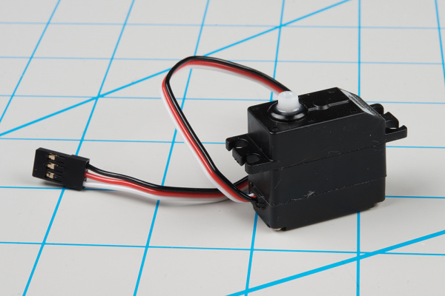

Check out [here](https://www.youtube.com/watch?v=gviUtLsHDtg) how it works!

 [Licença Creative Commons](http://creativecommons.org/licenses/by-nc/4.0/)